Erbil First School Museum and Archive

## Visit the First School in Erbil – a Unique School Museum in Iraq

Located in the historic centre of Erbil, the first school in Erbil was established in 1928 at the request of the people of the citadel of Erbil during the reign of King Faisal I. It was mostly attended by the urban upper class of Erbil, and many of its graduates became influential in Iraq and Kurdish history. The first school museum invites you to travel back in time, and to explore changes in the school’s practices and curriculum of this school over six decades.

Link to new page: Location

for future elaboration: [Read more]

## A place of lost Cultural Diversity

Placed in the centre of different neighbourhoods, in Erbil’s first school, male students of all ethnicities and religions that contributed to Erbil society – Kurds, Arabs, Turkmen, Muslims, Jews and Christians learned together until 1948, which was typical for Iraq urban society of this time. Due to policies of national and religious homogenization, cultural diversity was lost in the years to follow.

for future elaboration: [Read more]

## Explore school history through teacher ANd student biographies

What makes this school museums special is that we tell school history through the lens of the biographies of its teachers and students. Each exhibition hall is dedicated to one individual teacher or student. Explore the exhibition halls here (Link to new page: Rooms)

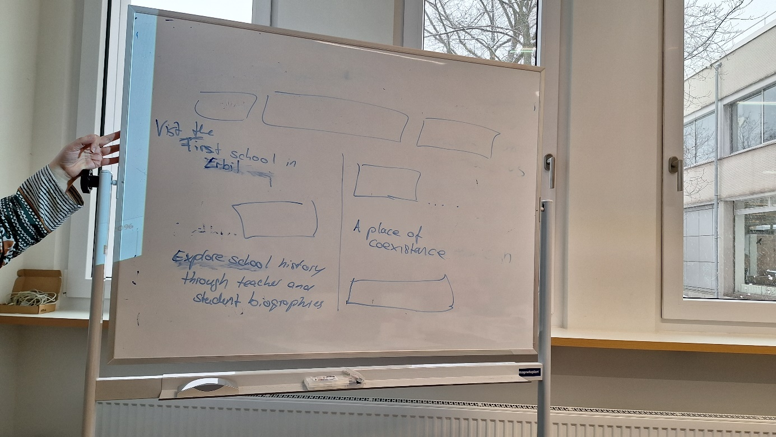

١- قاعة عبد الله عزيز وهو احد مدراء مدرسة اربيل الاولى ١٩٣٢ ومؤلف كتاب الصحة والاشياء على مستوى العراق.

2 - قاعة احمد ناجي وهو احد مدراء مدرسة اربيل الاولى ومشرف البناء وقتها ١٩٢٨-١٩٣٠ وهو مؤسس فكرة انشاء المدرسة

3- قاعة عز الدين فيضي احد مدراء المدرسة وهو كاتب وشخصية سياسية بارزة انذاك ١٩٦٣

4- عبد الواحد مرجان معلم وطالب تخرج من نفس المدرسة ليصبح بعدها احد رواد التربية الفنية (موسيقى، تمثيل، رسم) في سبعينيات القرن الماضي.

5- موسى خليل احد معلمي المدرسة كان له دور كبير في تدريس المتهج في خمسينيات القرن الماضي.

6- اسكندر عثمان تخرج وعمل في نفس المدرسة ودرس فيها وهو من رواد الفن التشكيلي انذاك في سبعينيات القرن الماضي.

Ground Floor

1- Abdullah Aziz Hall. Abdullah Aziz, one of the early principals of the First Erbil School, was a pioneer of secular education and an important school book author. He wrote “Health and Science” the most influential school book for science education in Iraq of its time.

2 - Ahmed Naji Hall. Ahmed Naji was the one who initiated the foundation of the school, supervised its construction and served as its principal from 1928-1934.

3- Ezzedine Fayzi Hall. Ezzedine Fayzi one of the school’s principals was a prominent intellectual and a teacher, whose progressive ways of teaching heavily influenced education in the 1960s.

4- Abdel Wahed Marjan hall. Abdel Wahed Marjan was an artist, who graduated from this school, and later became a teacher there. He was one of the pioneers of art education in the 1970s.

5 – This hall portrays more than 100 graduates from the school became in one way or the other important in society in Iraq.

~~5- Musa Khalil, one of the school’s teachers, had a major role in teaching spelling in the 1950s.~~

continue here

6- Iskandar Othman hall. Iskandar Othman was another artist who graduated from and taught at this school. He was one of the pioneers of fine arts in the 1970s.

الطابق الاول

7- علي حمادي مدرس الرياضة وله دور كبير في بطولات الرياضية للمدرسة في ستينات القرن الماضي.

8- قاعة الشهداء (خير الله عبد الكريم) وتضم اساتذة ومعلمين الذين استشهدوا في احداث مسيرة حرية كوردستان في القرن الماضي.

9- مصطفى شعبان معلم الاجيال في فترة الخمسينيات والستينات من القرن الماضي وهو شخصية تاريخية وسايسية معروفة. ويذكر انه قام بتدريس شخصيات سياسية مشهورة في تلك الفترة.

10- اسماعيل سرهنك وهو معلم صف العلوم وكان شغوفا بتربيته للنبات والزهور وكان له دو ركبير في االقيام باستكشاف الكثير من النباتات البرية والزهور الطبيعية في اقليم كوردستان.

11- شكرية جياوك وهي اول معلمة في اربيل ١٩٣٦ وكان لها دور كبير في تشجيع الكثير من البنات للانضمام والالتحاق بالمدرسة.

12- دانييال قصاب احد معلمي التربية الفنية في المدرسة في فترة الثلاثينيات والاربعينيات من القرن الماضي وهو من الديانة اليهودية سكن اربيل وقد تاسست الحركة الفن التشكيلي على يده في اربيل

13- خضر مولود احد ابرز مدراء المدرسة في اواسط فترة الستينات الى السبعينات من القرن الماضي حيث كان له دور بارز في تطوير المدرسة واهمها انشاء غرفة السينما المدرسية.

First floor

7- Ali Hammadi hall. Ali Hammadi, a sports teacher, played a major role in the school’s sports championships in the 1960s.

8- Hall of Khairallah Abdul Karim. This hall is dedicated to the memory of professors and teachers who sacrificed their life/were killed in the events of the Kurdistan Freedom March in the last century.

9- Mustafa Shaaban hall. Mustafa Shaaban was an outstanding teacher in the 1950s and 1960s. He established dormitories for students from poor families. Some of his pupils became famous political figures later, among them Mam Jalal al Talabani the former president of Iraq (2005-2014).

10- Ismail Sarhang hall. Ismail Sarhang was a dedicated science teacher in the 1970s. He was passionate about growing plants and played a great role in exploring and documenting the flora of the Kurdistan Region.

11- Shukriya Jiawk hall. Shukriya Jiawk was the first female Kurdish teacher in Erbil. Starting her career as a teacher in Erbil’s first girl school in 1936, she played a major role in encouraging Kurdish families to send their girls to school.

12- Daniel Qassab hall. Daniel Qassab was an art education teacher at the school in the 1930s and 1940s. He founded the fine art movement in Erbil. He was of Jewish faith and lived in Erbil, which he had to leave in 1951.

13- Khader Mouloud hall. Khader Mouloud, one prominent school principal (mid-1960s to 1970s), can be called a pioneer of media-education. He established a cinema room in the school.